Report for Assignment 2

Question 1

1. This code is saved in q1.py
2. The program is to approximate the square root

The input is any positive value

The output is is the approximated square root

1. Execute as followings:



Question 2

1. This code is saved in q2.py
2. The program can show the emirp (prime spelled backward) whose reversal is also a prime not including palindromic prime

No input.

Output is the first 100 emirps, 10 numbers per line.

1. Execute as followings:

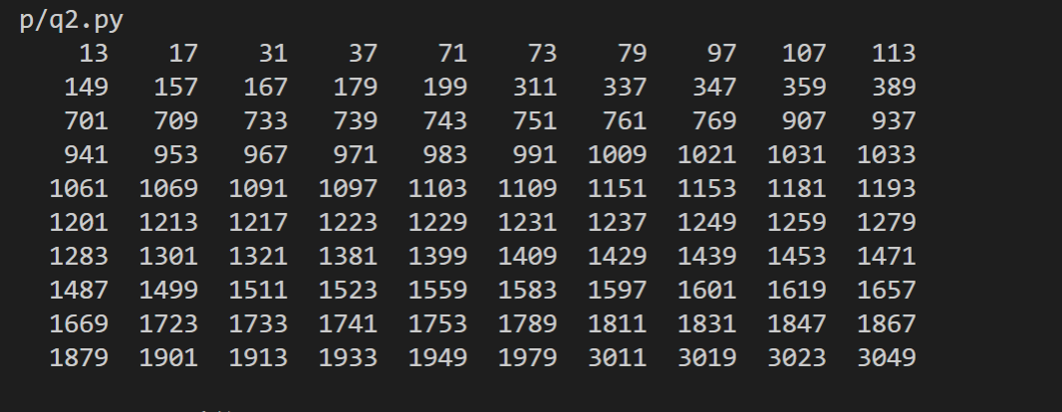

Question 3

1. This code is saved in q3.py
2. The program is to check the credit card number whether it is valid by the Luhn check.

The input is a credit card number which is a positive integer.

The output is to tell the user whether it is valid.

3.Execute as followings:



Question 4

1. This code is saved in q4.py
2. The program is to check whether two words are anagrams

Input: two strings

Output: The output is to tell the user whether it is anagram.

3.Execute as followings:

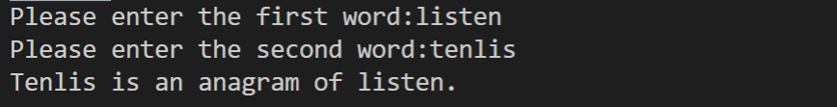

Question 5

1. This code is saved in q5.py
2. Locker puzzle: to show after 100 students operating on 100 lockers, the open lockers.( Nth student change every N lockers.)

No input.

Output: the open lockers numbers.

3.Execute as followings:

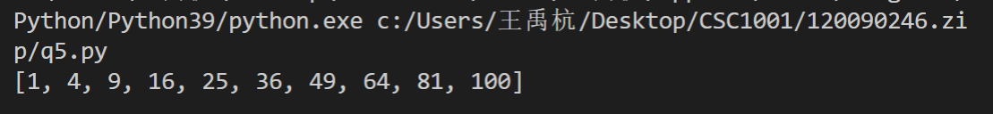

Question 6

1. This code is saved in qy6.py
2. To place eight queens on a chessboard (8\*8) such that no two queens can attack each other.

No inputs.

Output: the chessboard that is put eight queens on.

1. Execute as followings:

